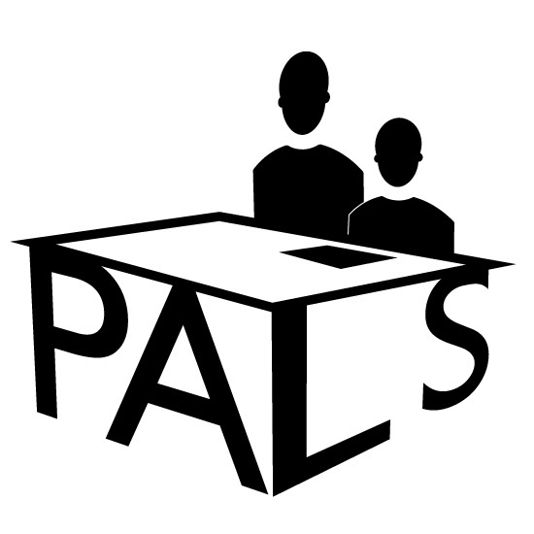
PALS: The Professional Association for Learning Support Inc

August 2021 Update

Hi Everyone,

We here at PALS know many of our members are involved in online learning or are supervising/teaching the students who are attending school. It has been a challenge and appears it will be for some time yet.

The start of this latest lockdown in Greater Sydney was on June 26…our 25th Birthday. Consequently our planned Birthday Celebration and Anne Kennedy Award Presentation were cancelled. Sad for us but a minor hiccup in the scheme of things.

We have held one webinar this term……ironically on Challenges for Secondary Learning and Support teachers. We plan to have one for primary members. We also looked at strategies for meeting these challenges.

Here’s hoping you find the material and ideas in the following links ( in blue) useful …. Just click on to access.
Professional Reading

Great Article on the teaching struggling readers
The Teaching of Reading

Castles article:
Ending the Reading Wars

Applying Response to Intervention for Secondary Students who struggle with Comprehension
Article on RtI

Resources
A site offering resources on early reading instruction…..FYI …..we have not used.
Really Great reading

Another site you might be interested in.
Reading Science Academy
MultiLit has announced the release of MiniLit Sage, a Tier 2 small group program for struggling readers in Year 1 and 2, providing explicit instruction in phonemic awareness, systematic synthetic phonics for reading and spelling, letter formation, and connected text reading.

OVER to You

Please share with your PALS colleagues anything you have found
useful…..would love to have for our newsletter to you. Just send to sec.pals@gmail.com

And please share our brochure with your colleagues. Let them know about PALS
You Tubes for you. The following may be of interest to you.

Inspiring the Students of the Future
Teaching Methods for Inspiring students of the Future Joe Ruhl
Word Chains
Word Chains Decoding and Encoding
Sorry not about how you can change your Principal
How Principal Can be a Change Maker
How to succeed at Remote Learning
Tips for Students

You have probably have seen a version of this cartoon…this new one captures another aspect. Might be useful for your PD

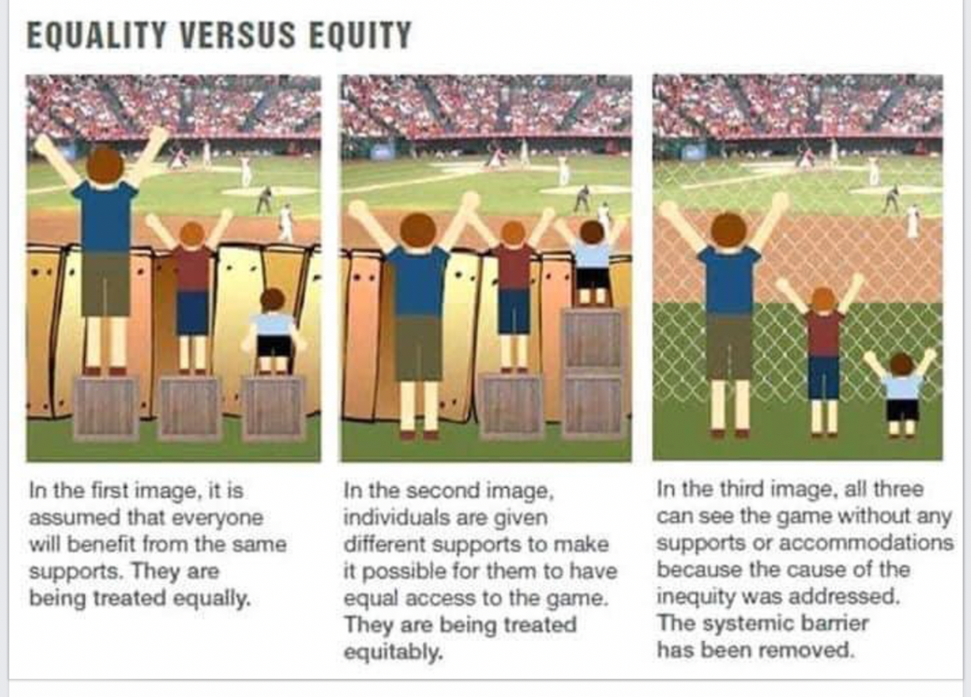

And this one is for fun…again you may have already seen it.

Upcoming Events
PALS We will be notifying you separately of our upcoming webinars

BUT our two relations in the world of Learning Support have online PD in the near future

LDA……a 6 week course on the Science of Writing Starting in October…online Monday evenings
https://www.trybooking.com/events/landing?eid=799730&

LD Coalition

The science of language and reading is for everyone Pamela Snow

Online 16th November 10:00 am to 12:00

Go to ldc.org.au

